IDEAL PLATFORM FOR AUTOMATION TESTING IN WEB

Why do we need automation?

The current industry trends have shown that there is a mass movement towards automation testing. Hence a cluster of repetitive manual testing scenarios has raised a demand to bring in the practice of automating these manual scenarios.

There are several benefits of implementing Automation Test & they are mentioned below-:

- Supports execution of repeated Test Cases
- Aids in testing a large Test Matrix
- Enables parallel execution
- Encourages unattended execution
- Improves accuracy thereby reducing human-generated errors
- Saves time and money
- Test automation helps accelerate regression test efforts in a cost effective manner, and allows constantly unattended execution

All the above mentioned benefits result in the following:

a. High ROI (Return On Investment)
b. Faster GoTo market (To enhance the overall customer experience)

There are several Automation testing benefits which are well understood and largely talked about in the software testing industry.

We can get the most benefit out of our automated testing efforts by automating:
- Repetitive tests that run for multiple builds.
- Tests that tend to cause human error.
- Tests that require multiple data sets.
- Frequently used functionality that introduces high risk conditions.
- Tests that are impossible to perform manually.
- Tests that run on several different hardware or software platforms and configurations.
- Tests that take a lot of effort and time when manual testing is done.

One of the most commonly asked questions that come with this are –

- What is the best tool for me to get my tests automated?
- Is there a cost involved in it?
- Is it easy to adapt?

These are the Top 5 Automation tools for 2018 -

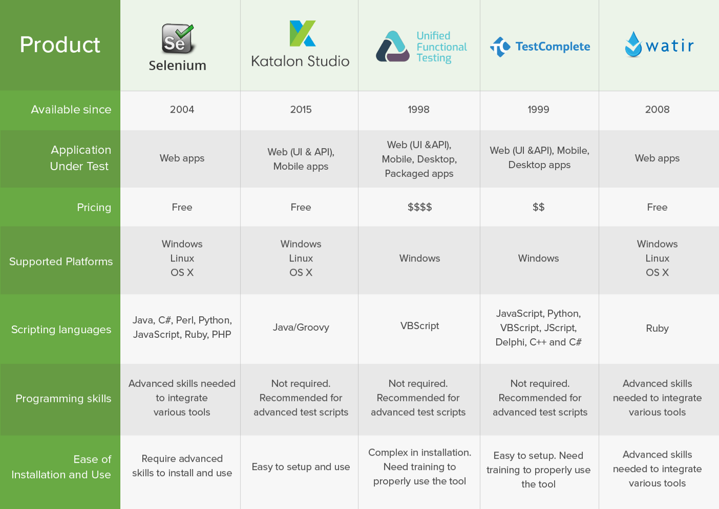
After the comparative study performed on the above mentioned automation tools.
We find one of the best answers to all the above questions for automating web-based applications in the form of Selenium.

Some of the reasons are mentioned below:

- It’s an open source
- It has a large user base and helping communities
- It has multi-browser and platform compatibility
- It supports multiple languages & framework implementations (TDD & BDD)
- It can operate and support across multiple Operating Systems (OS) like Windows, Mac, Linux, UNIX, etc
- It's support is community based and an active community support enable constant updates and upgrades
- It is not just a singular tool or utility, it is a loaded package of various testing tools and so is referred to as a Suite. Each tool is designed to cater to different testing needs and requirements of test environments.
- It offers a user-friendly interface that helps create and execute tests easily and effectively.
- Selenium Test Automation Framework uses scripts that can be tested directly across multiple browsers. Concurrently, it is possible to execute multiple tests with Selenium (Parallel Testing), as it covers almost all aspects of functional testing by implementing add-on tools that broaden the scope of testing.
- It can be implemented for Mobile web application automation on Android, IPhone, and Blackberry.

Below is the pictorial description of the advantages of Selenium in a nutshell-

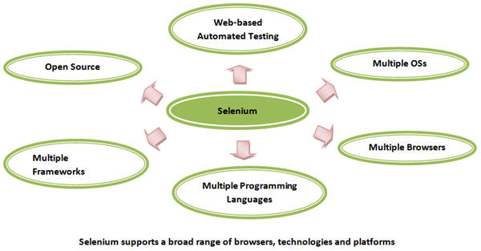

Drawbacks of Selenium when compared to UFT (near competitor of Selenium):

1) Limited support for Image based Testing in Selenium, but UFT has rich support for Image Testing.

2) Since Selenium is Open Source, new features may not work properly, but HP provides support for UFT / QTP New feature

Conclusion-

We can see by the number of merits in comparison to the drawbacks that we are getting while using Selenium compared to the other Web Automation Testing Tools in the market, Selenium should be the way to go forward.
Bottom line is that, it is most important to gather the knowledge of implementing a right approach & that comes only by experience.

Some of the tutorial links for reference-

Selenium tutorial blog & video series:

What Is Selenium? A Beginner's Guide To Automation Testing | Edureka

Selenium Tutorial - A Complete Tutorial on Selenium Automation Testing

http://www.naveenautomationlabs.com/

http://learn-automation.com/

https://www.seleniumhq.org/docs/

